- Miss Sweetheart of Summer Virtual Pageant
Monday, June 1st –Monday, June 22nd (3 weeks total)
Entry Form
Entry Fee: $39 (Ages 0-3), $49 (Ages 4 & Over)
(0-3, 4-6, 7-9, 10-12, 13-15, 16-18, 19 & Over, Mrs Division)
**0-3 Age Group compete in Casual Wear and Evening Gown ONLY**

Contestant Name:
Parent’s Names (if 18 or under): Age (On June 1st, 2020):
Email:
Facebook Name:
How did you find out about the pageant?

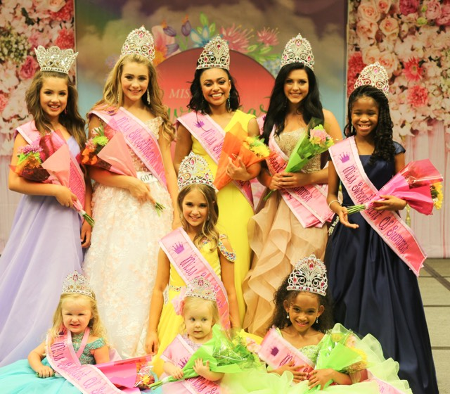

Competition Categories:
- Week 1: Casual Wear (Attire of your choice) Casual OR Dressy: 1/3 of Score
- Week 2: Evening Gown (Gown of your choice): 1/3 of Score
- Week 3: Interview (Will be recorded on your phone and sent into me privately on messenger. Top 5 in each division will have a live interview the final week of the pageant.): 1/3 of Score (3 & Under Division not included)

Optional Competition Categories (Not Required):
- Photogenic Competition: $10 per photo (unlimited for $25) ***Top 3 Awarded for the Pageant
- Talent Competition: $20 per Entry, Maximum 2 Talent Entries per contestant (**Top 3 awarded. Plaque to Overall Winner)
- Fun Fashion- $15 per Entry. Pattern will be the same as Casual Wear pattern
- (Please have ALL Optional Videos submitted by Sunday, May 14th, which is one week prior to the end of the pageant). (**Top 3 awarded. Plaque to Overall Winner)

**ALL FEES PAID ARE NON-REFUNDABLE

To pay online: You may pay via PayPal: Lforbes13@Hotmail.com, Venmo: @Lisa-Forbes-4

To pay be check: Lisa Forbes Cardello, 1 West 114th Terr, Kansas City, MO 64114

I hereby apply as an entrant in the 2020 Miss Sweetheart of Summer Pageant in the division marked with an “X” below, and I acknowledge and agree as follows:
PLEASE MARK YOUR DIVISION:

____ (0-3) ____ (4-6) _____ (7-9) (10-12) (13-15) ________ (16-18) ______ (19&Over) _____ (Mrs.)

Optional (Please place an X if participating):
______ (Photogenic/Optional) $10/photo, $25 Unlimited Photos
(Talent) $20/Each, Maximum 2 Talents Per Contestant
(Fun Fashion) $15/Entry Maximum 2 Entries per Contestant

Talent Description:

Official Rules/Details and Contestant Information:

Welcome!! We are excited to have you! Below is an outline on how the competition will work.

Each week, we will have a new category of competition and you will upload your HOMEMADE (non-professionally produced) video each Sunday night by midnight. We have 3 judges on our judging panel that will score your phase of competition from 1-10 and will also provide written feedback. You will receive all scores and feedback at the end of the pageant.

On Monday, 6/1, you will be added to the Private Miss Sweetheart of Summer Facebook Group Page. All competition will begin that day with further details.

**0-3 Age Group compete in Casual Wear and Evening Gown ONLY**

Video Submission Deadlines:
Week 1 (6/1): Casual Wear (Video Due, posted in the group and sent to my personal Facebook Messenger by Sunday, 6/7 by midnight.
Week 2 (6/8): Evening Gown please post in the group and also send to my personal Messenger.
Week 3 (6/15): Interview (Video Due EARLY by Wednesday, June 17th by midnight) Private message me, Lisa Forbes Cardello your interview videos. This way, your competition cannot see and view your answers and get an unfair advantage within the group. Each delegate with have 3 Questions to answer that is specific to her age division.)
Week 3: Friday, June 19th, All Top 5 Finalists will be announced and further details provided
Week 3: Saturday, June 20th will be the FINAL, TOP 5 Zoom Interview Calls
Week 3: Sunday, June 21st Winners will be announced LIVE!!!
Week of June 22nd- ALL Awards will be shipped out

RULES:
1.) Videos must be homemade. No professional stages, venues, production etc. These need to be made in the confines of your home, driveway, basement, backyard, etc.
2.) Music is allowed and at your discretion
3.) Please make sure you are in a well-lit area so judges can see and review your videos
4.) Please try your best to keep all videos under 1 minute in length. Doing these from your home allows you to do as many "takes" as you would like until you find your perfect one.
5.) DO NOT reach out to the judges for any reason during the course of this competition. Doing so will result in disqualification.
6.) Patterns and examples will be posted on Monday for each phase of competition (excluding interview)
7.) Photogenic- If you have entered photogenic, please pm me, Lisa Forbes Cardello your photos by Sunday, June 14th
8.) Props- no use of props are allowed during competition. Talent is allowed to have props.
9.) Fun Fashion Pattern(s) are identical to your Casual Wear Pattern. Please have these posted in the group AND sent to my messenger, Lisa Forbes Cardello, by Sunday, June 14th.
10.) Talent- Talent is to be something that you can do from home and also could be performed on stage at a live pageant. Please keep your talent under 2 minutes if possible. Please submit your Talent to me, Lisa Forbes Cardello by Sunday, June 14th.
11.) You may post your Talent & Casual Wear anytime in the group- this is at your discretion. However, they ultimately need to me send to my personal Facebook messenger by Sunday, June 14th.
12.) You will receive all scores and feedback by the end of the week of June 22nd after competition has ended. I will get these to you as quickly as possible. Please be respectful and not ask for them daily. I will have them to you by the end of the week after the pageant has concluded.

13.) All Awards & Trophies will be shipped by end of the week of June 22nd after competition has ended.
14.) Evening Gowns are encouraged to be Full Length
15.) Casual Wear outfits can be rompers, cocktail dresses, sundresses, or anything creative you have in your pageant wardrobe, or even in your closet! Please reach out if you need any help.
16.) Interview outfits should be something you would wear to a professional interview, church or pageant competition. No jeans.
17.) Each Week, you will receive the full instructions, patterns and sample video.
18.) Have fun and reach out if you have any questions!

Total: (Entry Fee + Optionals) = $__________

Contestant Name: Signature: Date:

Parent’s Name: Signature: Date:
(if under 18 years of age)

